Let’s explore two DC power supply designs. Suppose you have a 12V car battery (so its voltage is typically 13.8VDC) and you want to power some digital logic circuits that require 4.5-5.1VDC at 0-25mA. How do you do that? Exceeding 5.1V will blow up the logic circuits and below 4.5V they stop working reliably. Let’s compare two designs: a passive voltage divider (A) and a 1-transistor power supply (B).
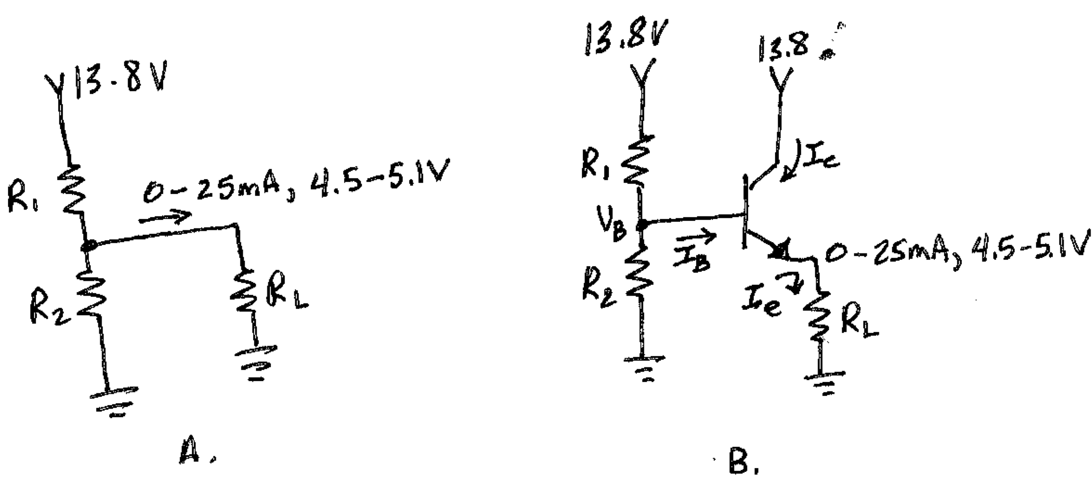
- Show that the digital circuits are equivalent (from the point of view of the power supply) to a load impedance > 180 Ohms.
- Design a voltage divider circuit with 2 resistors as your power supply (drawing A). Show that their values are around 38 and 65 ohms. (Hint: you’ll need 3 equations relating the 3 unknowns. One equation is R_{L} = 180Ω or ∞. You get multiple equations for R1 and R2 by analyzing the circuit under different extremes, like no load and maximum load).
- Show that this power supply draws ~1.8W of power with no load and 2W under full load. Show that its efficiency (power to load / total power used) is ~5%.
- Now build an equivalent power supply with an emitter follower (drawing B). Assume V_{BE} = 0.6V, h_{fe} = 100. Label all voltages and currents (more variables, more equations) under the two extreme values of R_{L} = 180Ω and ∞. Show the effective impedance the voltage divider sees “looking at” the base at full load is ~20kOhm.
- Show the voltage divider resistors should be 4kΩ and 5.8kΩ.
- Show this power supply uses ~19mW without load
- Under full load, show the transistor dissipates ~230mW (from the collector to emitter), and the efficiency of the fully loaded power supply is ~30%, five times better than the passive one. Remember, from the point of view of R_{L}, these two power supplies behave the same. But the transistor supply runs vastly cooler, delivering the same power to the load with much less waste.
- What key lessons did you learn from this exercise?

